C:\Users\Eliza\AppData\Local\Microsoft\Windows\Temporary Internet Files\Content.IE5\UF46B04I\aiga-drinking-fountain-bg[1].pngC:\Users\Eliza\AppData\Local\Microsoft\Windows\Temporary Internet Files\Content.IE5\39J57M6X\France_road_sign_C1a.svg[1].png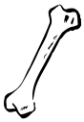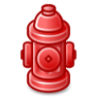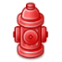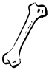C:\Users\Eliza\AppData\Local\Microsoft\Windows\Temporary Internet Files\Content.IE5\UF46B04I\aiga-drinking-fountain-bg[1].pngC:\Users\Eliza\AppData\Local\Microsoft\Windows\Temporary Internet Files\Content.IE5\39J57M6X\France_road_sign_C1a.svg[1].pngC:\Users\Eliza\AppData\Local\Microsoft\Windows\Temporary Internet Files\Content.IE5\39J57M6X\France_road_sign_C1a.svg[1].pngC:\Users\Eliza\AppData\Local\Microsoft\Windows\Temporary Internet Files\Content.IE5\39J57M6X\France_road_sign_C1a.svg[1].png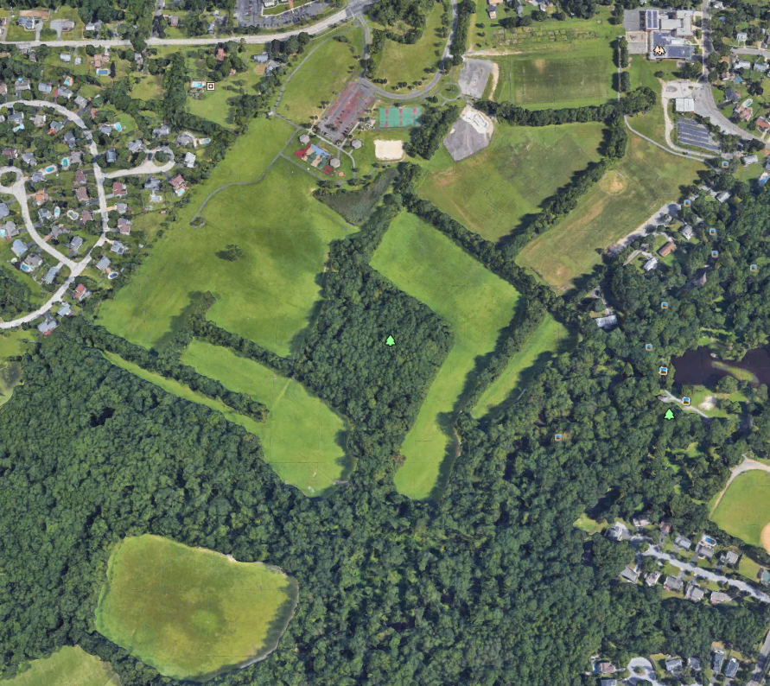

Hartford Rd.

Union St.



Un-named trails



Buddy Trail



Trash can & Dog Waste Receptacle

Lucy Trail

Max Trail

Roxy and Rex Trail

Shiloh Trail

Roxy Trail



Park Boundary

Water Fountain – Dog/Human

Parking Lots

Creek location

Entrances

Blue Squirrel Field

White Dog Bone Field

Yellow Dog House Field

Red Fire Hydrant Field

**LEGEND:**



Gil Rd.

Old Marlton Pike