Dr. James Still

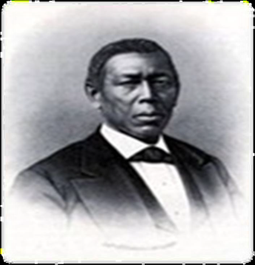
The Man

- James Still, the son of formerly enslaved parents, Charity and Levin, was born and raised in Indian Mills. As an adult, he called Medford “home,” eventually building a large Second Empire Victorian styled house with all available luxuries on Church Road in 1869. He resided there with his wife and family until his death in 1882.
- He overcame the challenges of little formal education, poverty and social expectations to earn respect and success as an herbalist with a large, diverse clientele. He became known as “Dr. Still” and prospered through strength of character, intelligence, hard work, thrift and saving, giving credit to “Providence”. Upon his death, he received recognition as one of the wealthiest men in Burlington County.
- Dr. Still believed in the potential for greatness in all human beings, regardless of race, gender, sex, class or religion. In his 1877 autobiography, The Early Recollections and Life of Dr. James Still, he stated, “All persons are born with certain gifts, which sooner or later develop in them, and I think those gifts should be cultivated, let them be of what sort they may be, so that they lead to honorable pursuits.”

The Family
- Dr. Still’s brother was William Still, activist, abolitionist, and noted author of the classic, “The Underground Railroad” published in 1872. He amassed a fortune of nearly $1 million as a coal merchant.
- Two other older brothers, Levin and Peter, were sold to a man in Lexington, Kentucky after their mother escaped to freedom around the turn of the century. Peter’s story was written by white abolitionist, Kate Pickard, and published in 1856. Samuel Still, a younger brother, continued to work nearby as a farmer and was regarded as a man of great character.
- Members of the Still family who continue to be recognized for significant accomplishments live throughout southern New Jersey and beyond.
- The Dr. James Still restoration project has been energized through the efforts of members of the Still family along with the contributions of time, talent, and goods of hundreds of community volunteers.

The Property
- The property that continues to house Dr. James Still’s medical office was purchased by the State of New Jersey in 2006. This purchase was the first and only State acquisition of an African American historic site in New Jersey.
- Restoration of this site and development of the property as an educational center are the shared goals of the State of New Jersey, Township of Medford, and the Historical Society of Medford. Their mission is to develop an educational center that will tell the Still family story so that all people of all ages and backgrounds, in their quest to fulfill their personal mission, may learn from it, be inspired and have their lives enriched by it.

Fulfilling the Mission
- Restoration: Restoring the property and surrounding grounds will require the support and assistance of professional and volunteer staff. The State Department of Environmental Protection has begun the process through a mowing and clearing of brush from the property. Extensive efforts and resources will be needed to complete the process. Grants will be written while local and state resources of labor, product, and expertise will be necessary to complete the effort.
- Community Education/Outreach: An extensive calendar of programs/events is available on our Facebook page. Of special note is the Juneteenth Celebration: Africans in America that will be held at the Historic Site & Center on June 7th. See details on reverse side of this page.
- Oversight for the Dr. James Still Project: The State of New Jersey owns the properties at 209-211 Church Road. The Medford Historical Society has been authorized to oversee the development of the Dr. James Still historic medical office, education center, and related programs at these properties through a Special Use Permit signed with the State of New Jersey in June 2013. No other individuals, for profit or non-profit groups have been authorized to do so.

Want to learn more? Please contact us at drstillcenter@gmail.com or
visit us on Facebook https://www.facebook.com/drjamesstill.

